6주차 실습과제

20135151 이갑성

1.

<소스>

import java.util.Scanner;

public class List {

int count;

public List(int count) { // 생기화

this.count = count;

}

public void input() {

Scanner sc = new Scanner(System.in);

String name[] = new String[count];

for (int i = 0; i < count; i++) {

System.out.print("[" + i + "]input data: ");

name[i] = sc.next();

}

System.out.println("");

for (int j = 0; j < count; j++) {

System.out.println("[" + j + "] = " + name[j]);

}

}

}

import java.util.Scanner;

public class Main {

public static void main(String[] args) {

Scanner sc = new Scanner(System.in);

int count;

System.out.println("How many data?");

count = sc.nextInt();

List list = new List(count);

list.input();

}

}

<출력>

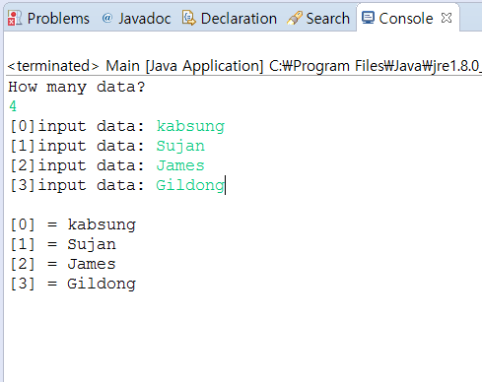

2.

<소스>

public class Polynomial {

int arr[];

int max;

int size;

int degree;

public Polynomial(int max) {

this.max = max;

arr = new int[max];

size = 0;

degree = 0;

}

public void isEmpty() {

if (size > 0)

System.out.println("it is not empty");

else

System.out.println("it is empty");

}

public int length() {

return size;

}

public void insert(int jisu, int gesu) {

arr[jisu] = gesu;

size++; //size = size + 1;

if (jisu > degree) {

degree = jisu;

}

}

public int retrieve(int jisu) {

return arr[jisu];

}

public void replace(int jisu, int regesu) {

arr[jisu] = regesu;

}

public void delete(int jisu) {

arr[jisu] = 0;

size = size - 1;

}

public void Print() {

int i;

for (i = degree; i >= 0; i--) {

if (arr[i] != 0) {

System.out.print(arr[i] + "[" + i + "]");

if (i > 0)

System.out.print("+");

}

}

System.out.println(" ");

}

public void addEO(Polynomial p1) {

int result[] = new int[100];

System.out.println("add result: ");

if (p1.degree > degree) {

for (int i = 0; i <= p1.degree; i++) {

result[i] = p1.arr[i] + arr[i];

}

for (int j = p1.degree; j >= 0; j--) {

if (result[j] != 0) {

System.out.print(result[j] + "[" + j + "]");

if (j > 0) {

System.out.print("+");

}

}

}

} else if (degree > p1.degree) {

for (int i = 0; i <= degree; i++) {

result[i] = arr[i] + p1.arr[i];

}

for (int j = degree; j >= 0; j--) {

if (result[j] != 0) {

System.out.print(result[j] + "[" + j + "]");

if (j > 0) {

System.out.print("+");

}

}

}

}

}

}

import java.util.Scanner;

public class Main {

public static void main(String args[]) {

Scanner sc = new Scanner(System.in);

int max;

System.out.println("배열의 크기 값을 입력하세요: ");

max = sc.nextInt();

Polynomial p1 = new Polynomial(max);

Polynomial p2 = new Polynomial(max);

p1.insert(0, 3);

p1.insert(1, 5);

p1.insert(5, 4);

p1.isEmpty();

System.out.println("length " + p1.length());

System.out.println(p1.retrieve(5));

p1.replace(2, 6);

p1.insert(2, 1);

System.out.println("length " + p1.length());

p1.delete(1);

System.out.println("length " + p1.length());

System.out.println(p1.retrieve(2));

p2.insert(10, 3);

p2.insert(8, 5);

p2.insert(5, 4);

p2.insert(2, 2);

p2.insert(0, 7);

p1.Print();

p2.Print();

p2.addEO(p1);

}

}

<출력>

